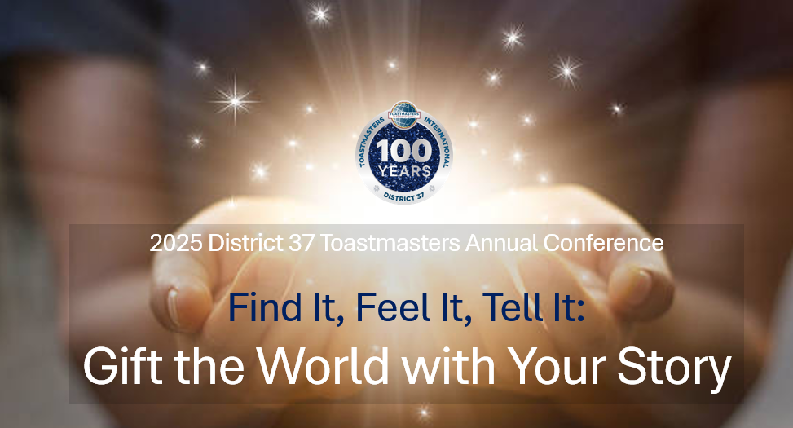

Calling District 37 Toastmasters!
Seeking Club Groups or Individual Speakers for our 2025 Annual Conference…

Are you or your club interested in facilitating one of four sessions at the 2025 Annual Conference on Saturday, May 2, 2025? If the answer is YES…
- Complete the Conference Speaker Application and return it to Dawn Webb at lorice720@yahoo.com.
- Applications must be received no later than 11:59 p.m. on Sunday, March 2, 2025.
Topics/Themes of choice are:
- Getting the best out of your Toastmasters Journey
- Storytelling Types / Best Practices
- How and when to use Humor
- Evaluation Tips / Best Practices

NOTE: For Club Groups, one person can submit as the main group contact.

