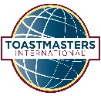
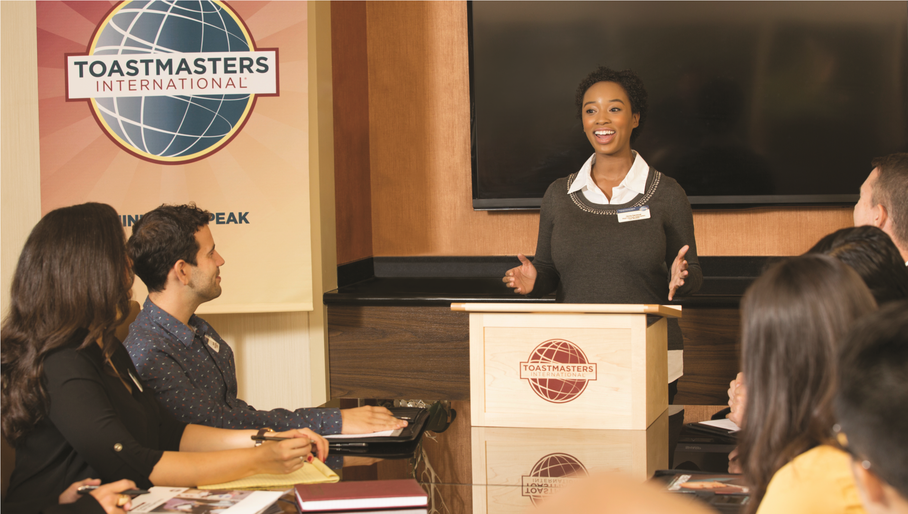
Contest/Pathways speeches – 5-7 minutes in length
In person only – Bring your Introduction and Evaluation Sheet
2 Speeches per person (3 if time permits)
Speaking order decided by Speakerthon Chair
Speakers please arrive at 9:45AM

Light refreshments provided
Café on-site
This Photo by Unknown Author is licensed under CC BY
This Photo by Unknown Author is licensed under CC BY
© 2017 Toastmasters International. All rights reserved.
Item VBP006
10/2017
Saturday, January 24th, 2026 10:00am-2:00pm
Forsyth County Central Library, (Auditorium)
660 West 5th Street, Winston-Salem

Contact: Jesse Wheeler (President) - jessewheeler10@gmail.com
Sherman Transou (VP Membership) - srtransou2@gmail.com

Winston-Salem Toastmasters
invites you to their
SPEAK-A-THON
Participate in the Speakathon:

- Speak with confidence
- Improve your communication skills
- Practice your contest speech
- Opportunity to complete your Pathways Levels 1 & 2
- Supported by experienced Toastmasters
- 1st Timer – Icebreaker and all levels welcome
- Constructive written evaluations given
- Family and Friends welcome

